**MANUAL**

Names: Eleni Katsi

Marianna Mina

Louiza Agroti

Maria Kouppi

**Screen Login:** **2**

**Screen Contact us (manager/employee):** **3**

**Screen View hours (manager/employee):** **4**

**Screen Clock in:** **5**

**Employee Status:** **5**

**Add employee:** **6**

**Leave Request (manager/employee):** **7**

**Logout**

### Screen Login:

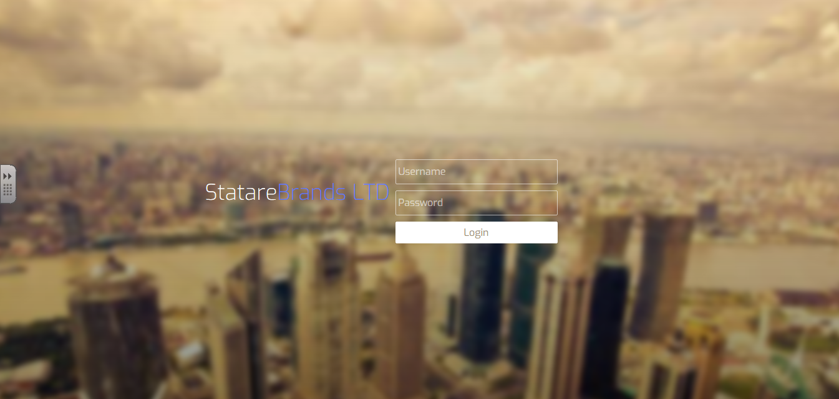

This screen is the Login screen in which each employee can have access to the system.

He/she have to put the username and the password to the corresponding field at first and then to press the button ‘Login’ to move to the next page which is the ‘Clock in’ screen.

### Screen Contact us (manager/employee):

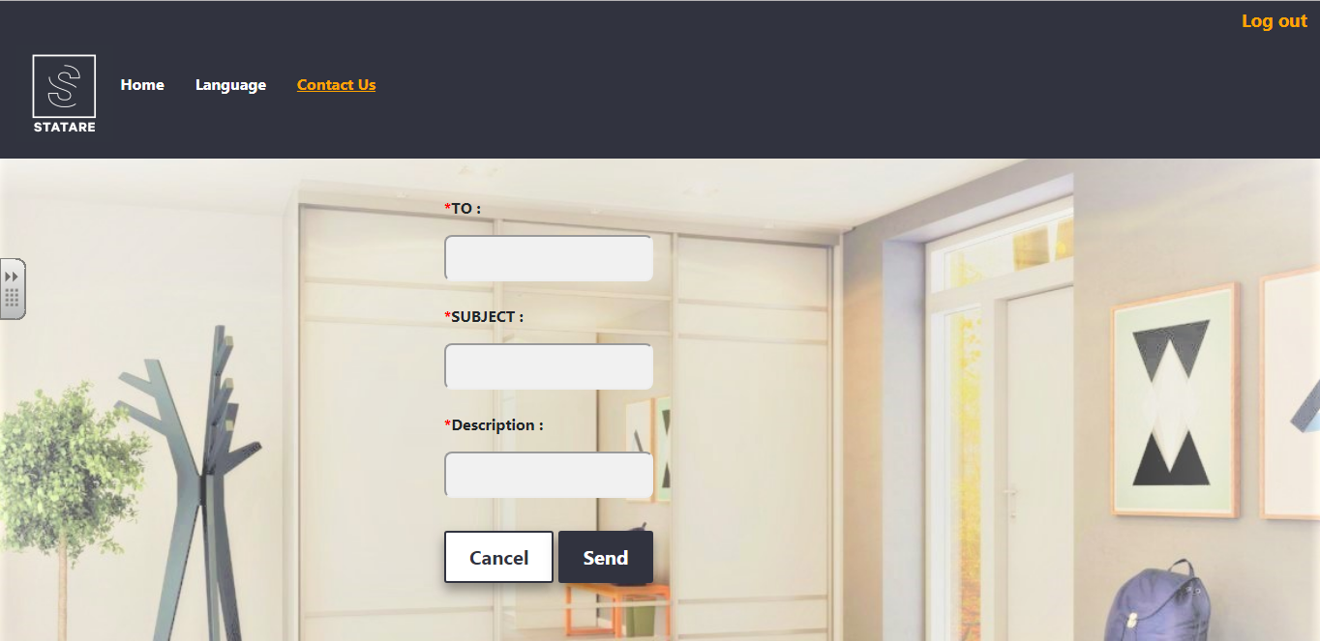

This screen gives the chance to an employee to send an email to another employee.

‘To’ , ‘Subject’ and ‘Description’ fields are required to complete from the employee.

If an employee don’t complete at least one of this fields, the email will not be send. When the three fields are complete, pressing the button ‘Send’, an alert box will appears and pressing the button ‘OK’ the email will be send to the email which is written in the field ‘To’ and your screen will be your Dashboard. At the alert box pressing the button ‘Cancel’, the email will not be send and you will stay on the same screen (Contact us screen). If you press the button ‘Cancel’ which is on the screen, an alert box will appears and pressing the button ‘OK’, the email will not be send and the screen now will be your Dashboard. At the alert box pressing the button ‘Cancel’, you will stay on the same screen (Contact us screen).

### Screen View hours (manager/employee):

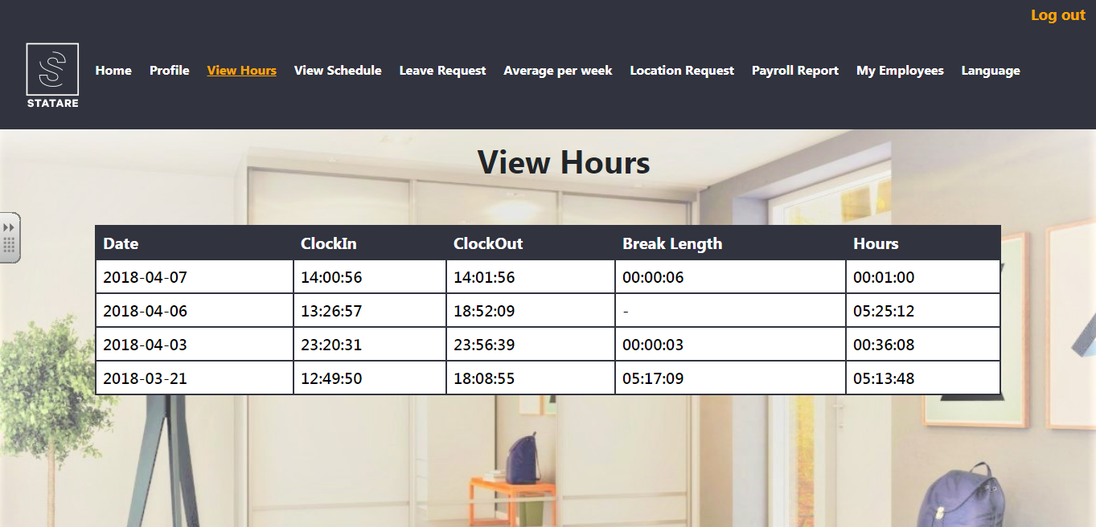

This screen gives the opportunity to an employee to see the situation in which he/she is.

He/she can see the time of clock in and clock out of each day. Also for each day he/she can see the length of his/her break and the full hours of work.

### Screen Clock in:

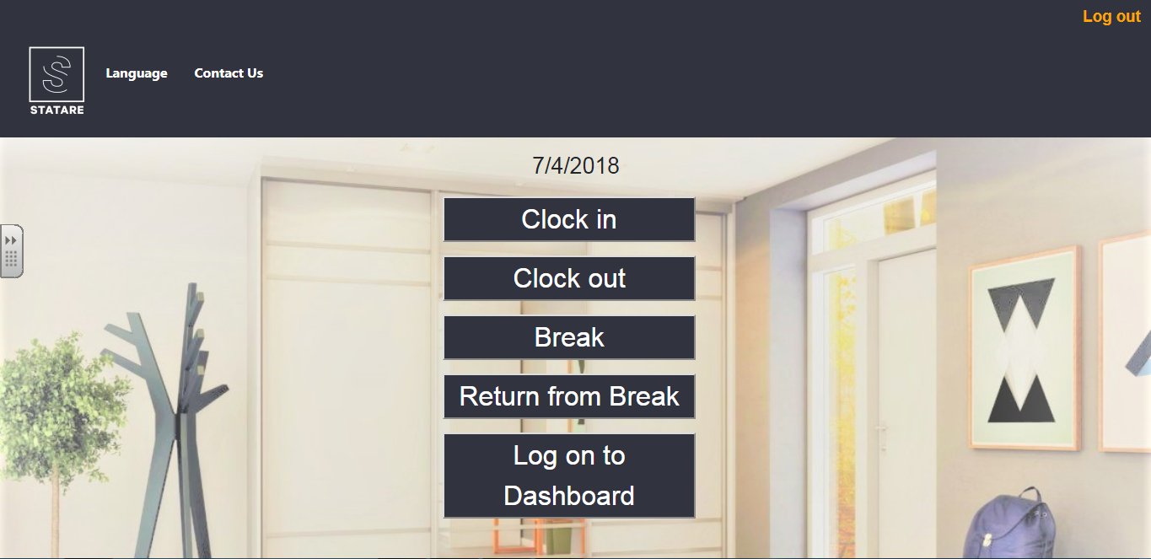

This screen gives the opportunity to an employee to do clock in, clock out, break, return from break and to log on Dashboard. Employee can’t press clock out before press clock in first, also can’t press return from break before press break first. As well if an employee is clocked in and is in break, he/she can’t press clock out. He/she have to press return from break first and then clock out.

### Employee Status:

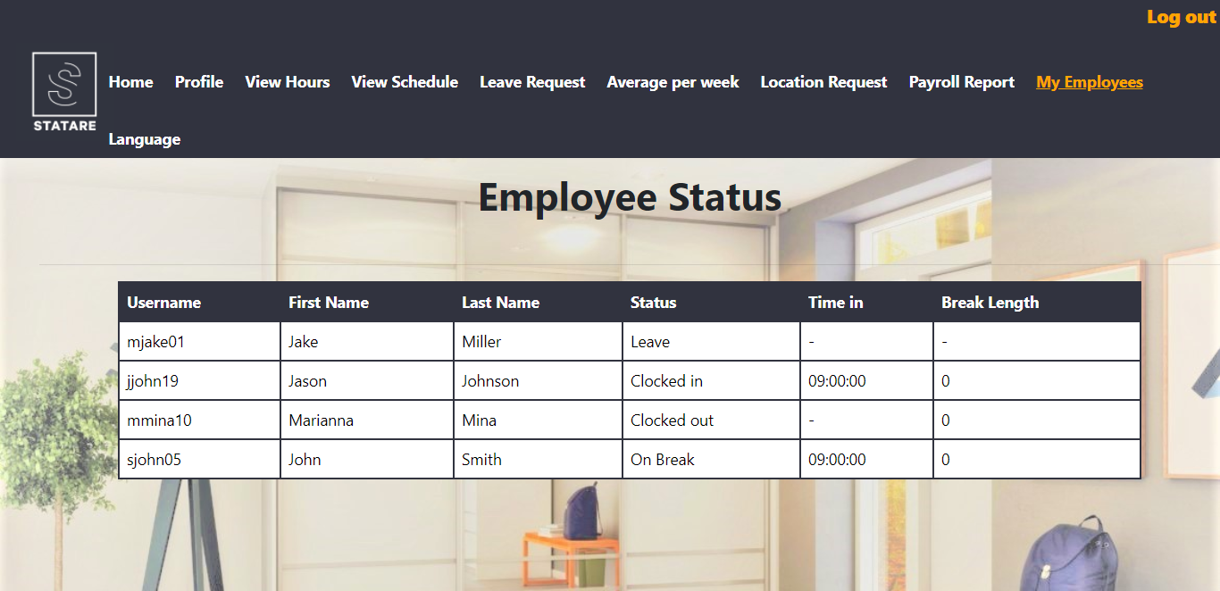

Employee Status screen gives the opportunity to managers to see the status of their employees. Status of an employee can be either on leave, clocked in, clocked out or on break. Manager can also see how much time each of his/her employees were on break from the last time that were clocked in.

### Add employee:

Add employee screen gives the opportunity to managers to add an employee. A manager must give the username, password, ID, SSN, First Name, Last Name, Department, Role,Working Country(in which country the current Department that manager gave is at), Salary, Salary Type(Fixed, Part Time,etc), phone, emergency phone, email and if employee is a manager or not (field Manager). Despite the required data that a manager must give, he/she can also give the country, address and date of birth of employee. After inserting correctly the above data, manager can save the changes he/she made by clicking the button Save (and at the pop confirmation window, by clicking ok) or he/she cancel his/her action either by clicking the button Save(and at the pop confirmation window, by clicking cancel) or by clicking the button Cancel(and at the pop confirmation window, by clicking ok or cancel).

### Leave Request (manager/employee):

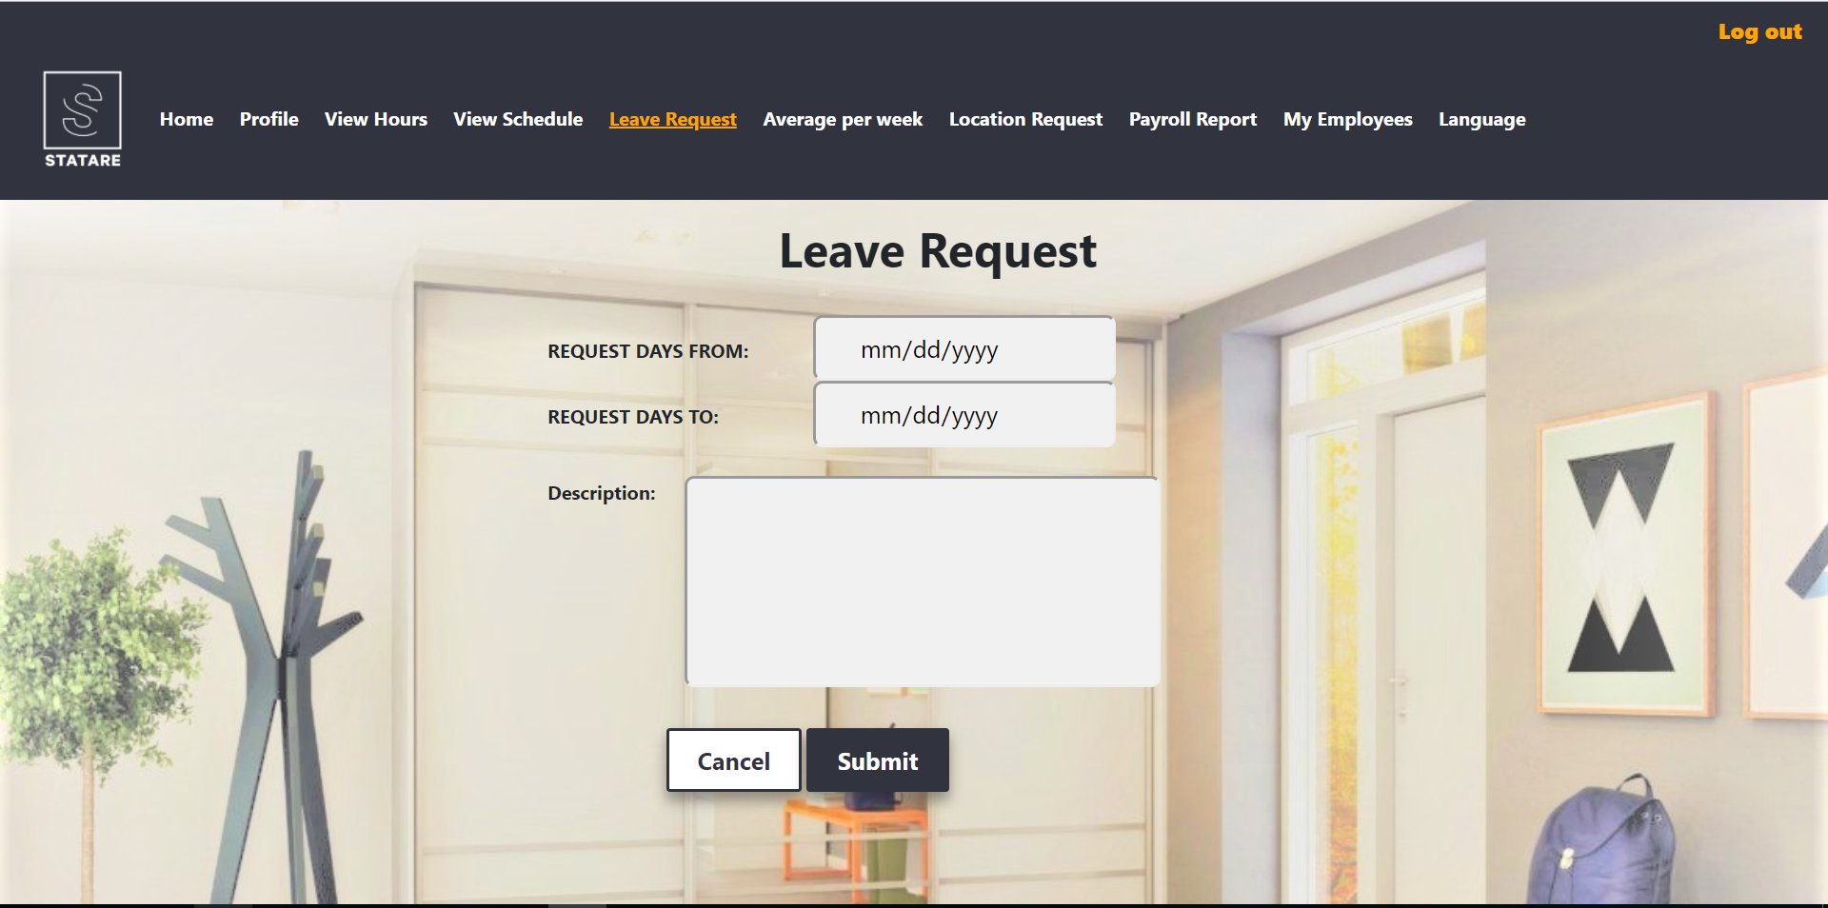

Leave Request screen gives the opportunity to managers and employees to request for leave. The employees or manager give the date which want to start the leave, the date which want to return from leave and the reason which want to leave. For example, summer holidays, doctor appointment etc. When the three fields are complete, pressing the button ‘Submit’, an alert box will appears and pressing the button ‘OK’ the request will be submit to the database. At the alert box pressing the button ‘Cancel’, the request will not be submit and you will stay on the same screen (Leave Request screen). If you press the button ‘Cancel’ which is on the screen, an alert box will appears and pressing the button ‘OK’, the request will not be submit and the screen now will be your Dashboard ( manager or employee). At the alert box pressing the button ‘Cancel’, you will stay on the same screen (Leave Request screen).

### Logout:

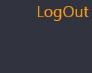

This button gives the opportunity to an employee to Log out from the system. If an employee is not clocked in, then is okay to press log out. If he/she is clocked in, he/she can’t press log out if he/she didn’t press clock out first. If he/she is clocked in and is in break, he/she can’t press log out if he/she didn’t press return from break first.